**Name : Đinh Gia Bảo**

**Student ID: SE183741**

**LAB 3: SYSTEM ATTRIBUTES AND**

**USING WORD PROCESSOR**

**Content :**

1. **Process Management**
2. **Some System Commands**
3. **Using the Editor Program vi**

**Submission :**

Upload the word file to cms describes some questions as :

• Present the content of manipulating of some command **(including syntax, what does it for?, examples)** as

* vmstat (view status of virtual memory)
* pstree –np
* pgrep <option> <parameter>: list process following name, properties ...
* pkill
* uptime
* free

• Capture the terminal screen using the vi application to view the content of file that are typed by you.

**I . PROCESS MANAGEMENT**

1. *View process status(ps) of the running process on the system: The “****ps****” command*

Syntax :

ps *option(s)*

Process status, information about processes running in memory. If you want a repetitive update of this status, use top.

**Ex1 : $ ps**

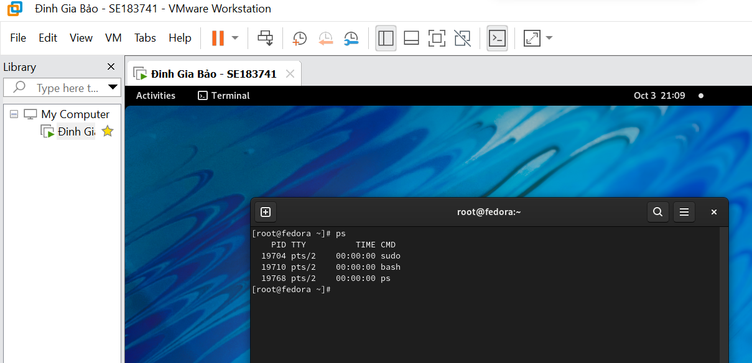

Check process status

**Ex2 : $ ps -a**

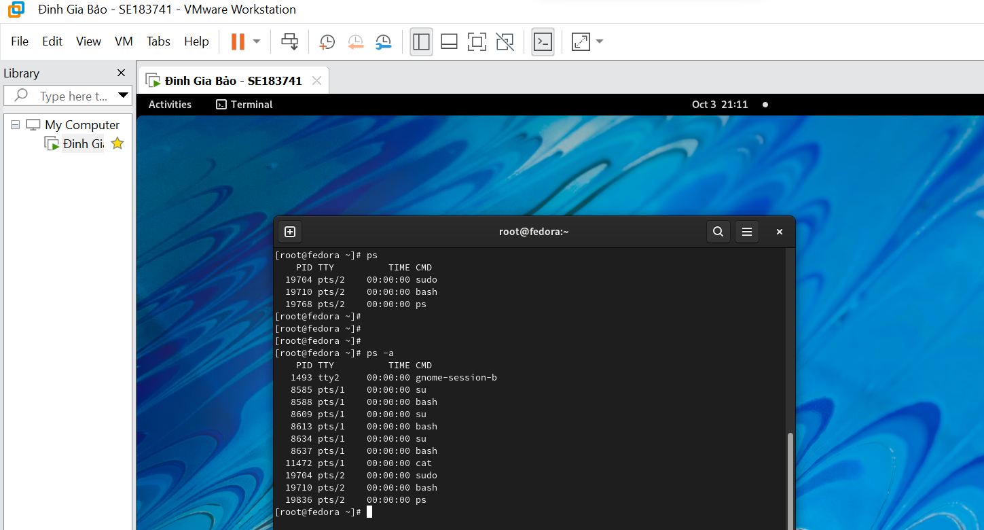

Select all processes, including those of other users.

**Ex3 : $ ps -axl**

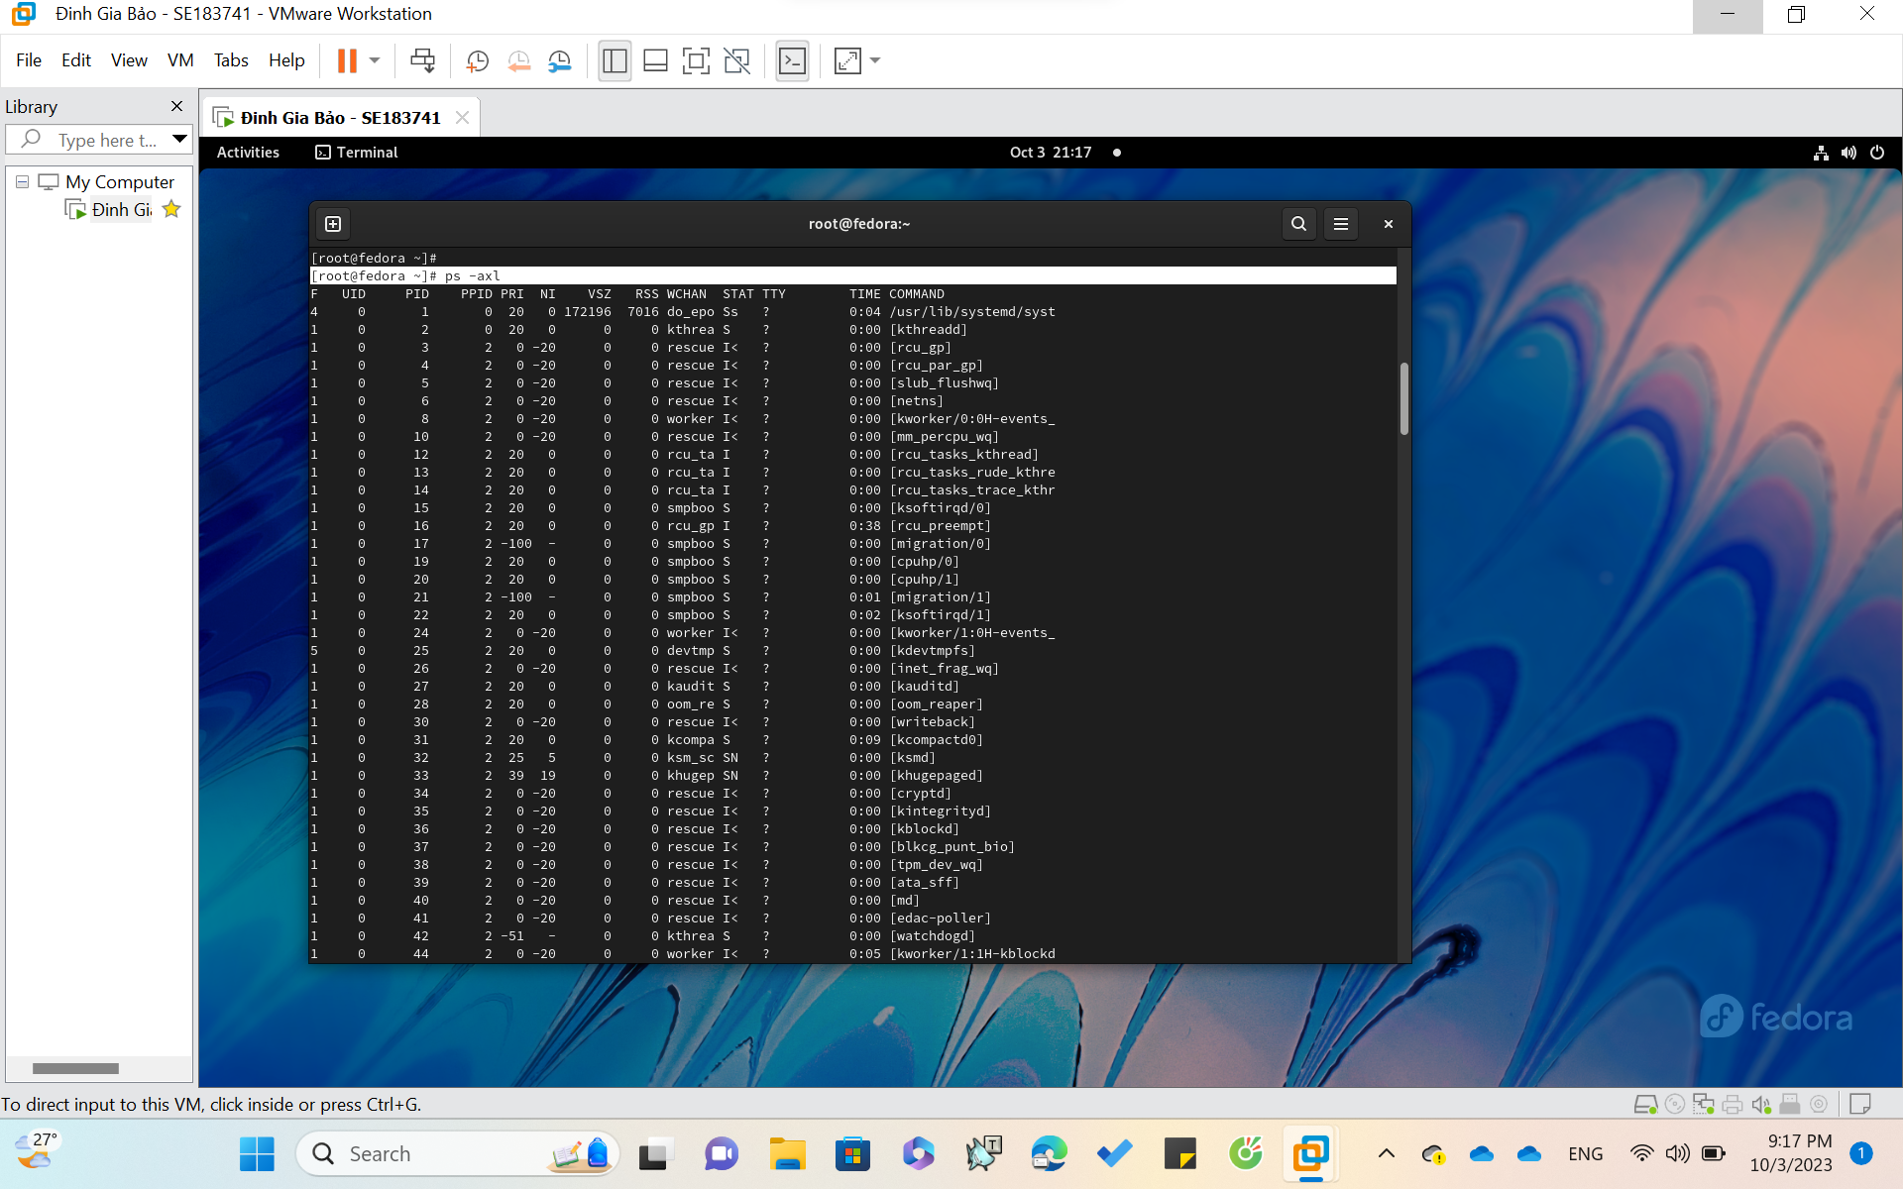

View all process with the full command

1. *Stop a process ( the* ***kill*** *command ) – Kill a process by specifying its PID*

Syntax

kill [-s *sigspec*] [-n *signum*] [-*sigspec*] *jobspec* or *pid*

kill -l [*exit_status*]

kill -l [*sigspec*]

Kill a process by specifying its PID, either via a signal or forced termination.

**Ex : $ kill -KILL PID**

*or shorter as* **$ kill -9 PID**

With **PID** is Process ID ( ex: 63772 )

* Purpose: Send a KILL signal to forcefully terminate a process immediately ( cannot be blocked )

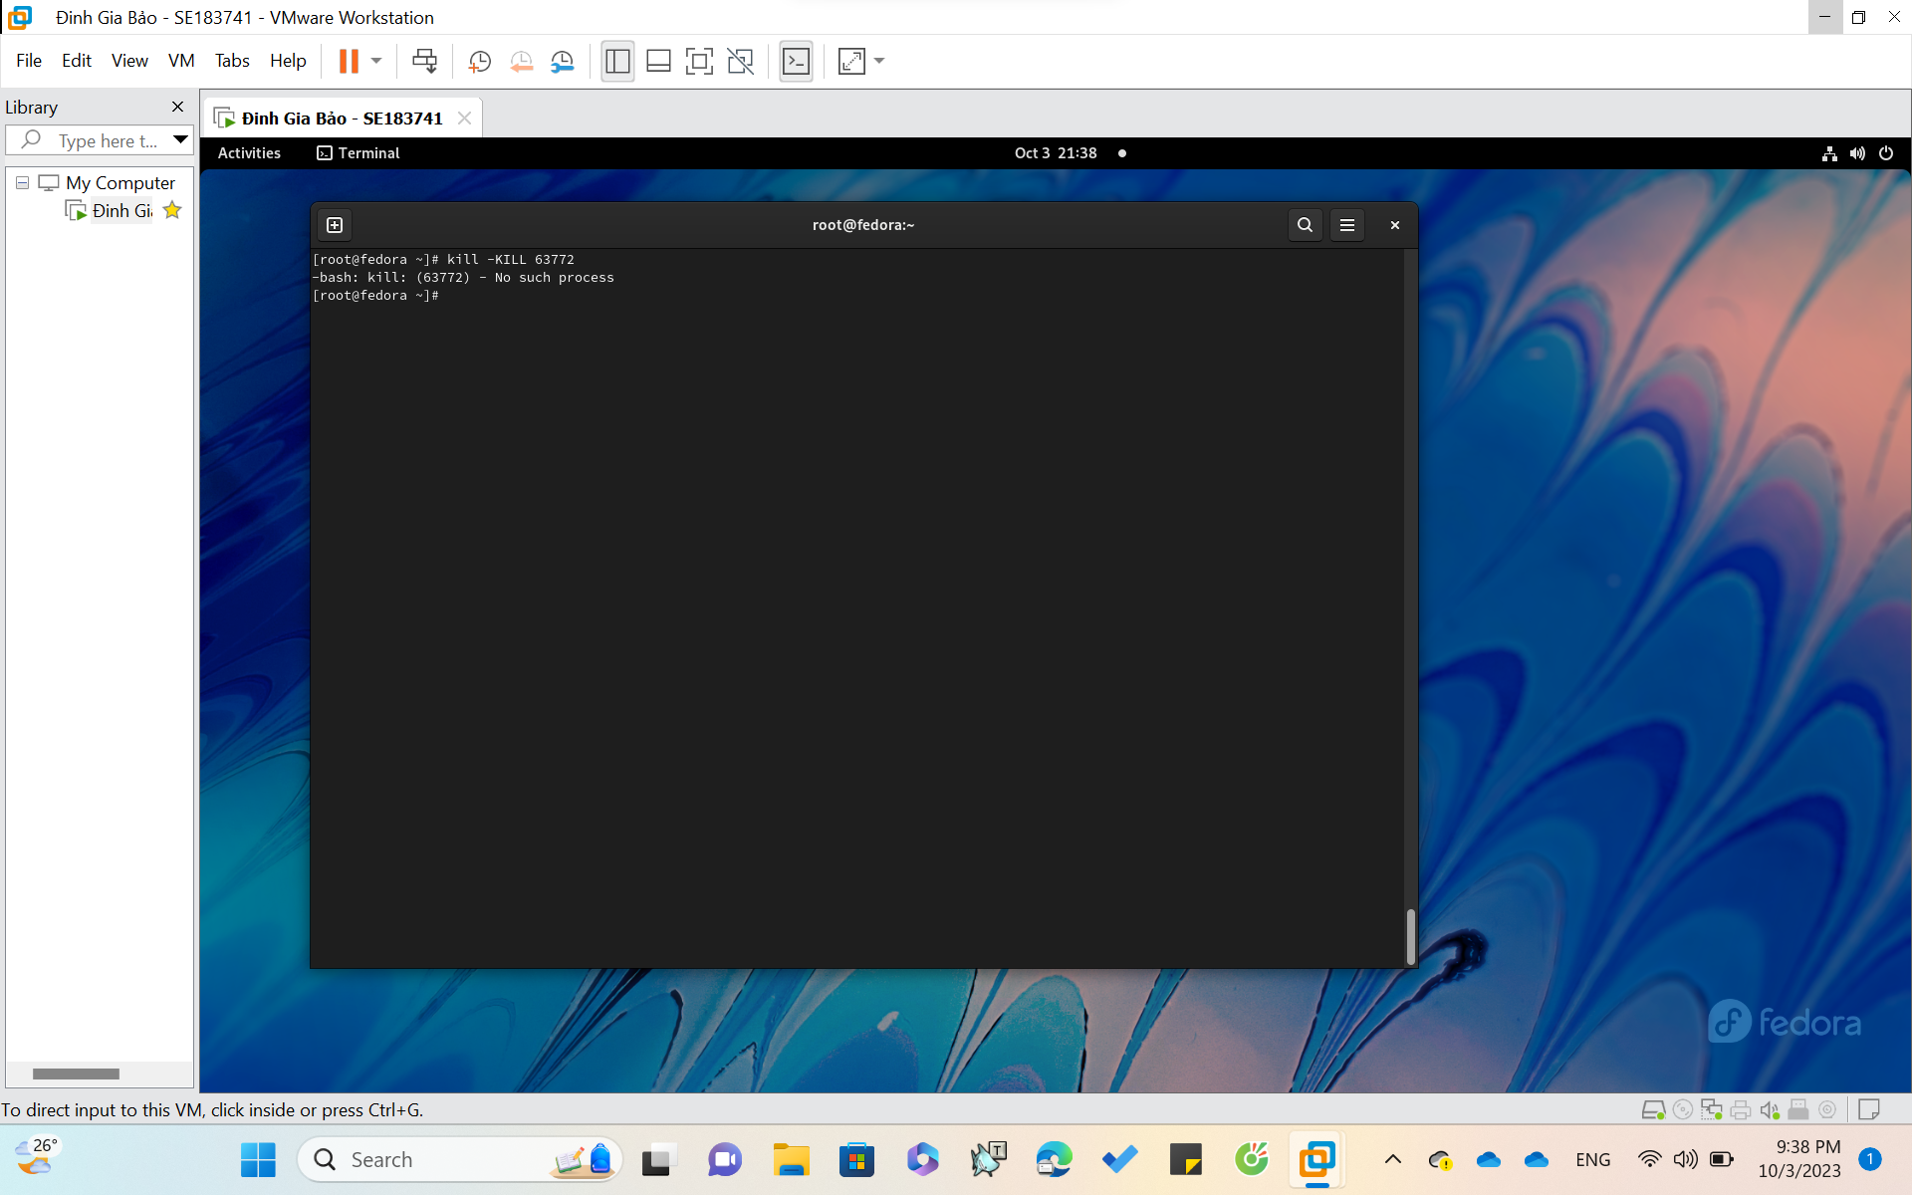

**II . SOME SYSTEM COMMAND**

**vmstat : Report virtual memory statistics**

Syntax

vmstat [-a] [-n] [*delay* [ *count*]]

vmstat [-f] [-s] [-m]

vmstat [-S unit]

vmstat [-d]

vmstat [-p *disk-partition*]

vmstat [-V]

**Ex: $ vmstat**

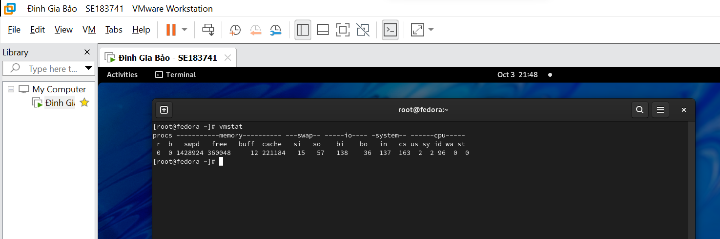

**pstree -np**

**Process Management:**

**Pstree**

Syntax: ps [-option] with [-option] are :

-a: view all

-ax: view all process, even though the process is not concern with tree

-axl: view all process with the full command

**Ex:**

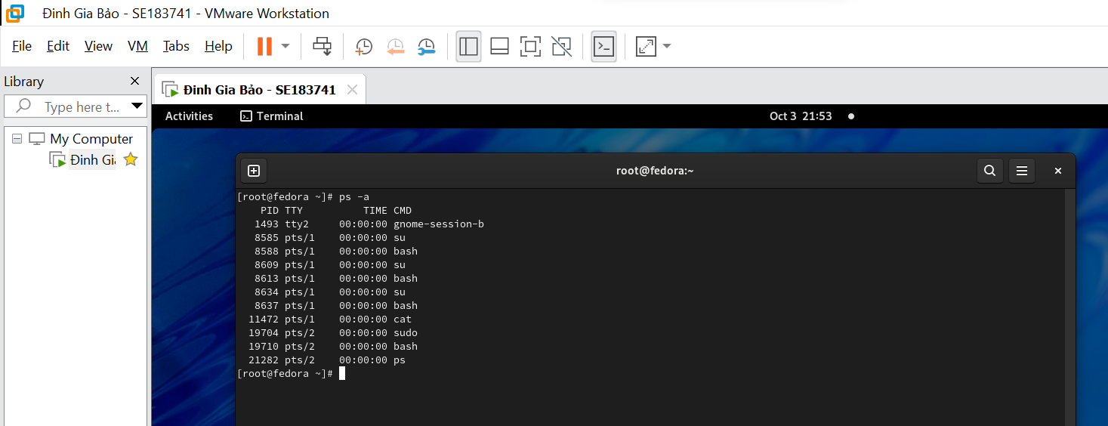

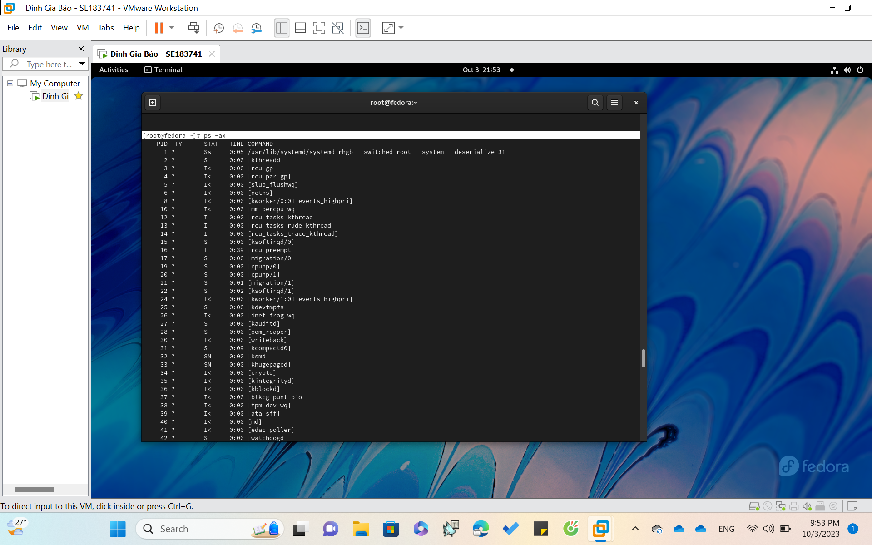

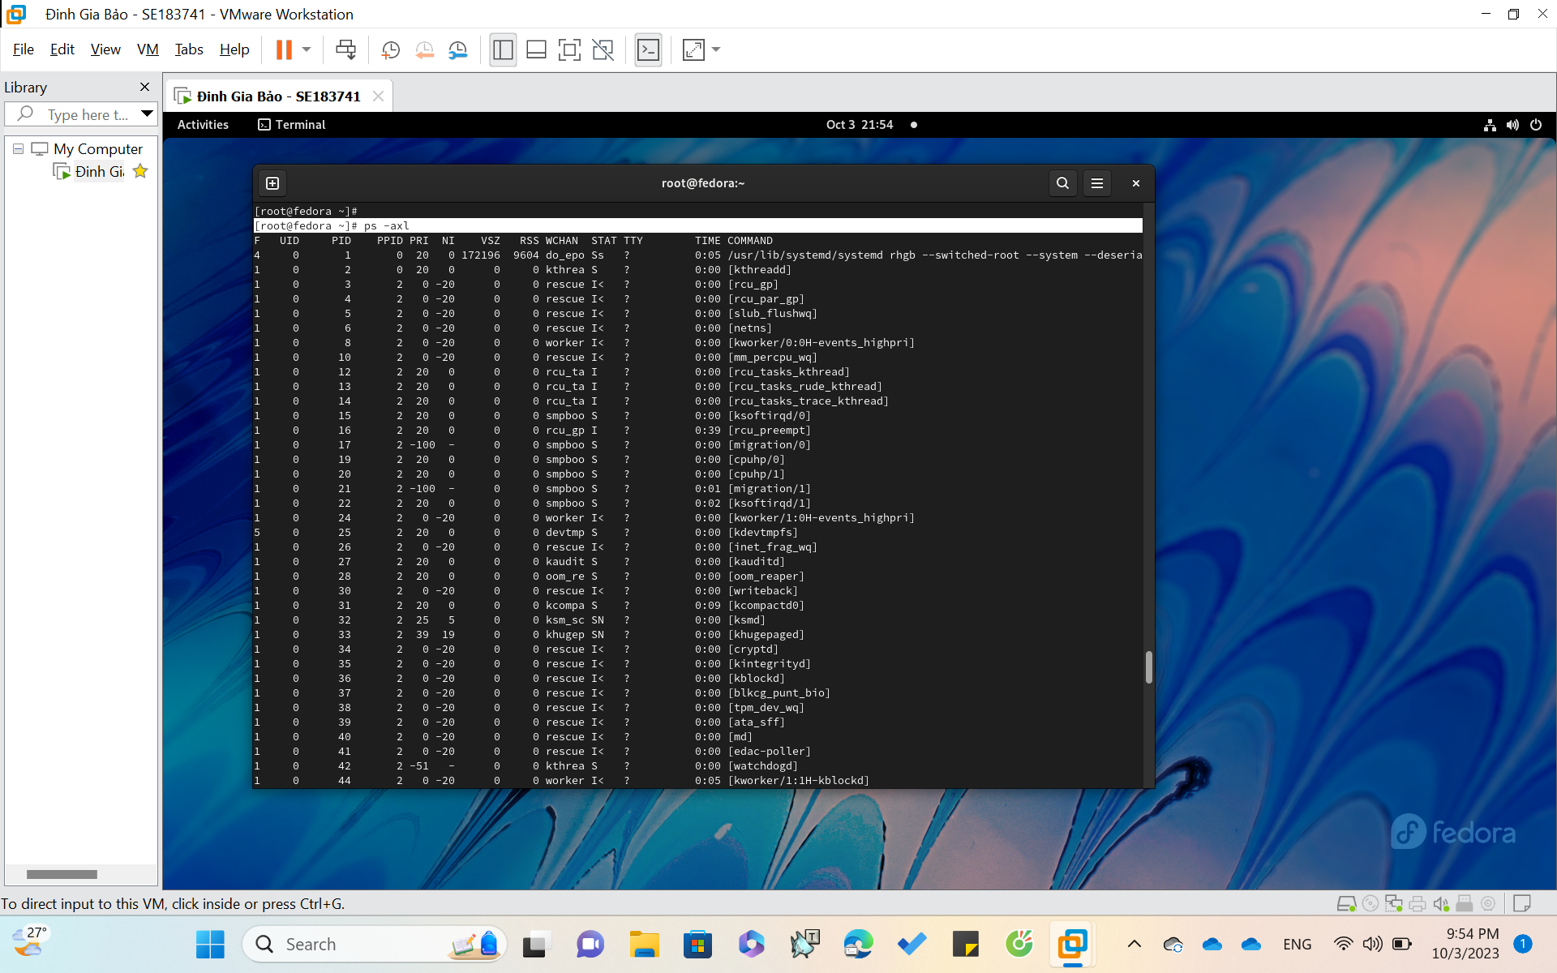

**pgrep: ( List processes by name )**

**Syntax:**

pgrep [-flvx] [-d *delimiter*] [-n|-o] [-P *ppid*,...] [-g *pgrp*,...]

[-s *sid*,...] [-u *euid*,...] [-U *uid*,...] [-G gid,...]

[-t *term*,...] [*pattern*]

pkill [-signal] [-fvx] [-n|-o] [-P *ppid*,...] [-g *pgrp*,...]

[-s *sid*,...] [-u *euid*,...] [-U *uid*,...] [-G *gid*,...]

[-t *term*,...] [*pattern*]

**Kill processes by a full or partial name.**

**Ex: $ pgrep -u root named**

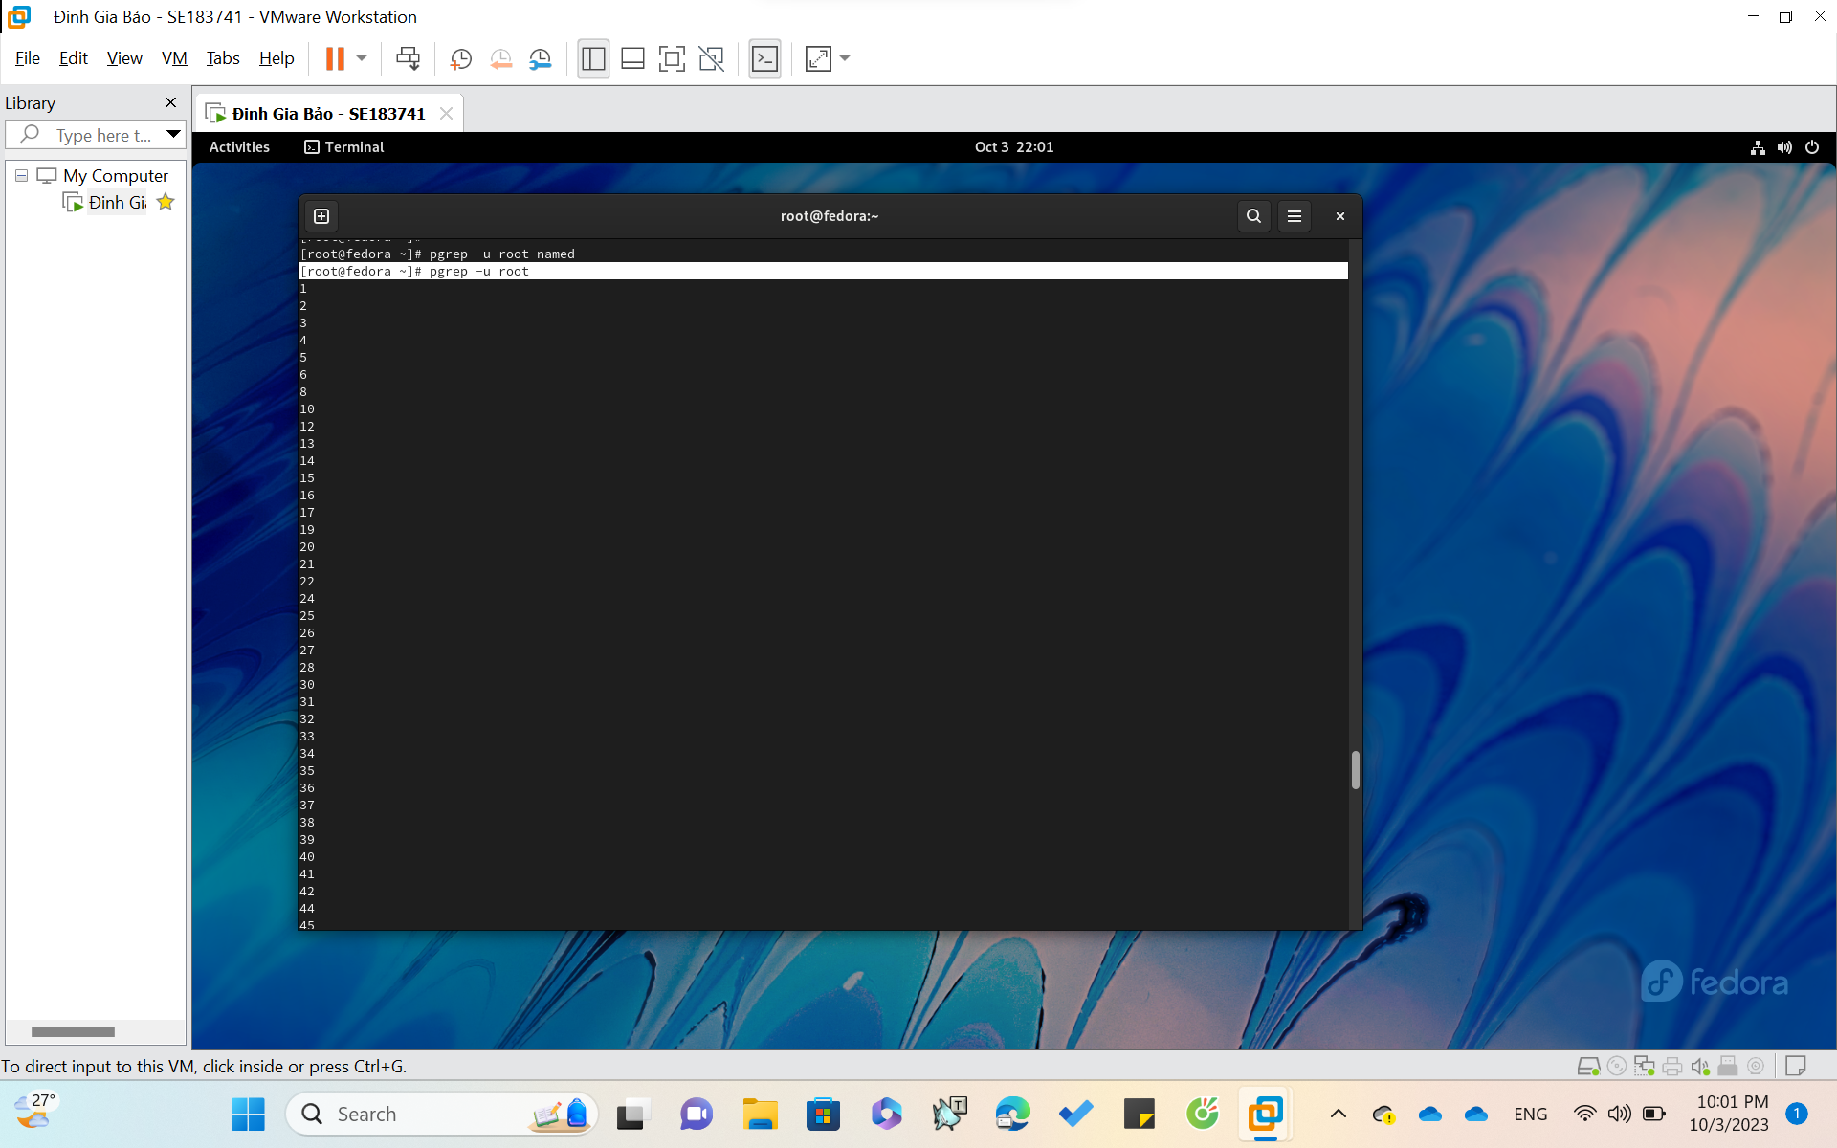

**Find the process ID of the named daemon**

**pkill: ( Stop a process )**

Syntax

kill [-s *sigspec*] [-n *signum*] [-*sigspec*] *jobspec* or *pid*

kill -l [*exit_status*]

kill -l [*sigspec*]

Kill a process by specifying its PID, either via a signal or forced termination.

**Ex : $ kill -KILL PID**

*or shorter as* **$ kill -9 PID**

With **PID** is Process ID ( ex: 63772 )

* Purpose: Send a KILL signal to forcefully terminate a process immediately ( cannot be blocked )



**In the first situation,if you cannot kill the process.**

**In the second, your terminal willimmediately exit.**

**uptime: ( show uptime )**

**Uptime Command In Linux:**

It is used to find out how long the system is active (running). This command returns set of values that involve, the current time, and the amount of time system is in running state, number of users currently logged into.

Syntax: uptime [-options]

**Ex1 : $ uptime**

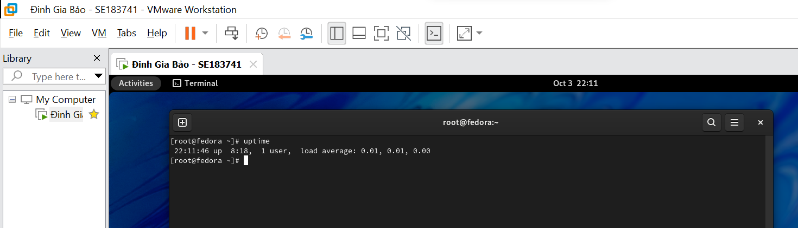

**Ex2 : $ uptime -p**

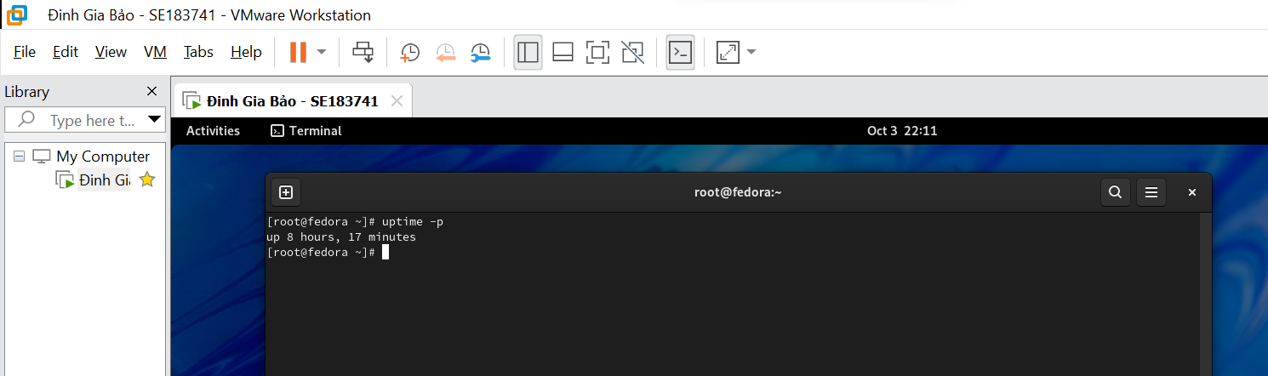

**free: ( display memory usage )**

In LINUX, there exists a command line utility for this and that is free command which displays the total amount of free space available along with the amount of memory used and swap memory in the system, and also the buffers used by the kernel.

Syxtax: $free **[OPTION]**

**OPTION** : refers to the options compatible with free command.

**Ex :**

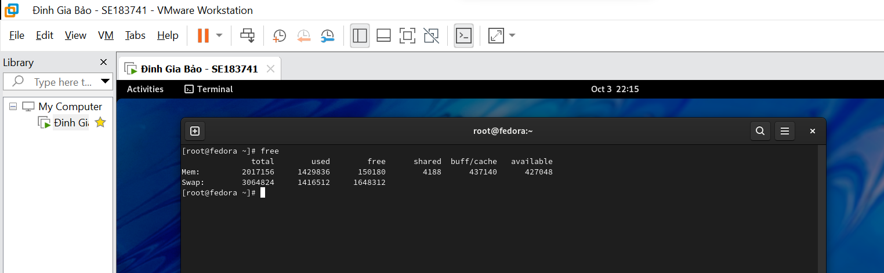

**III . USING THE EDITOR PROGRAM vi**

* **Syntax: vi <file_name>**

Firstly, I want to create a file named “**test2.txt**” in **Lab03** directory

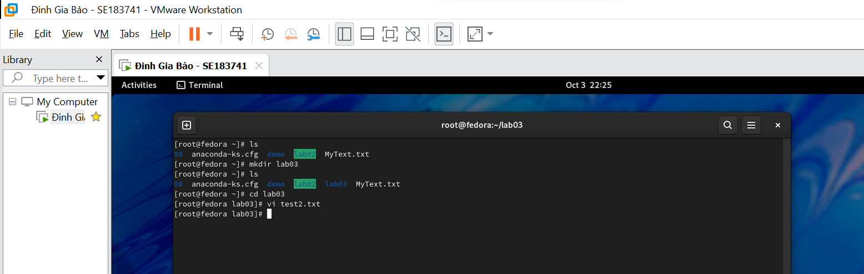

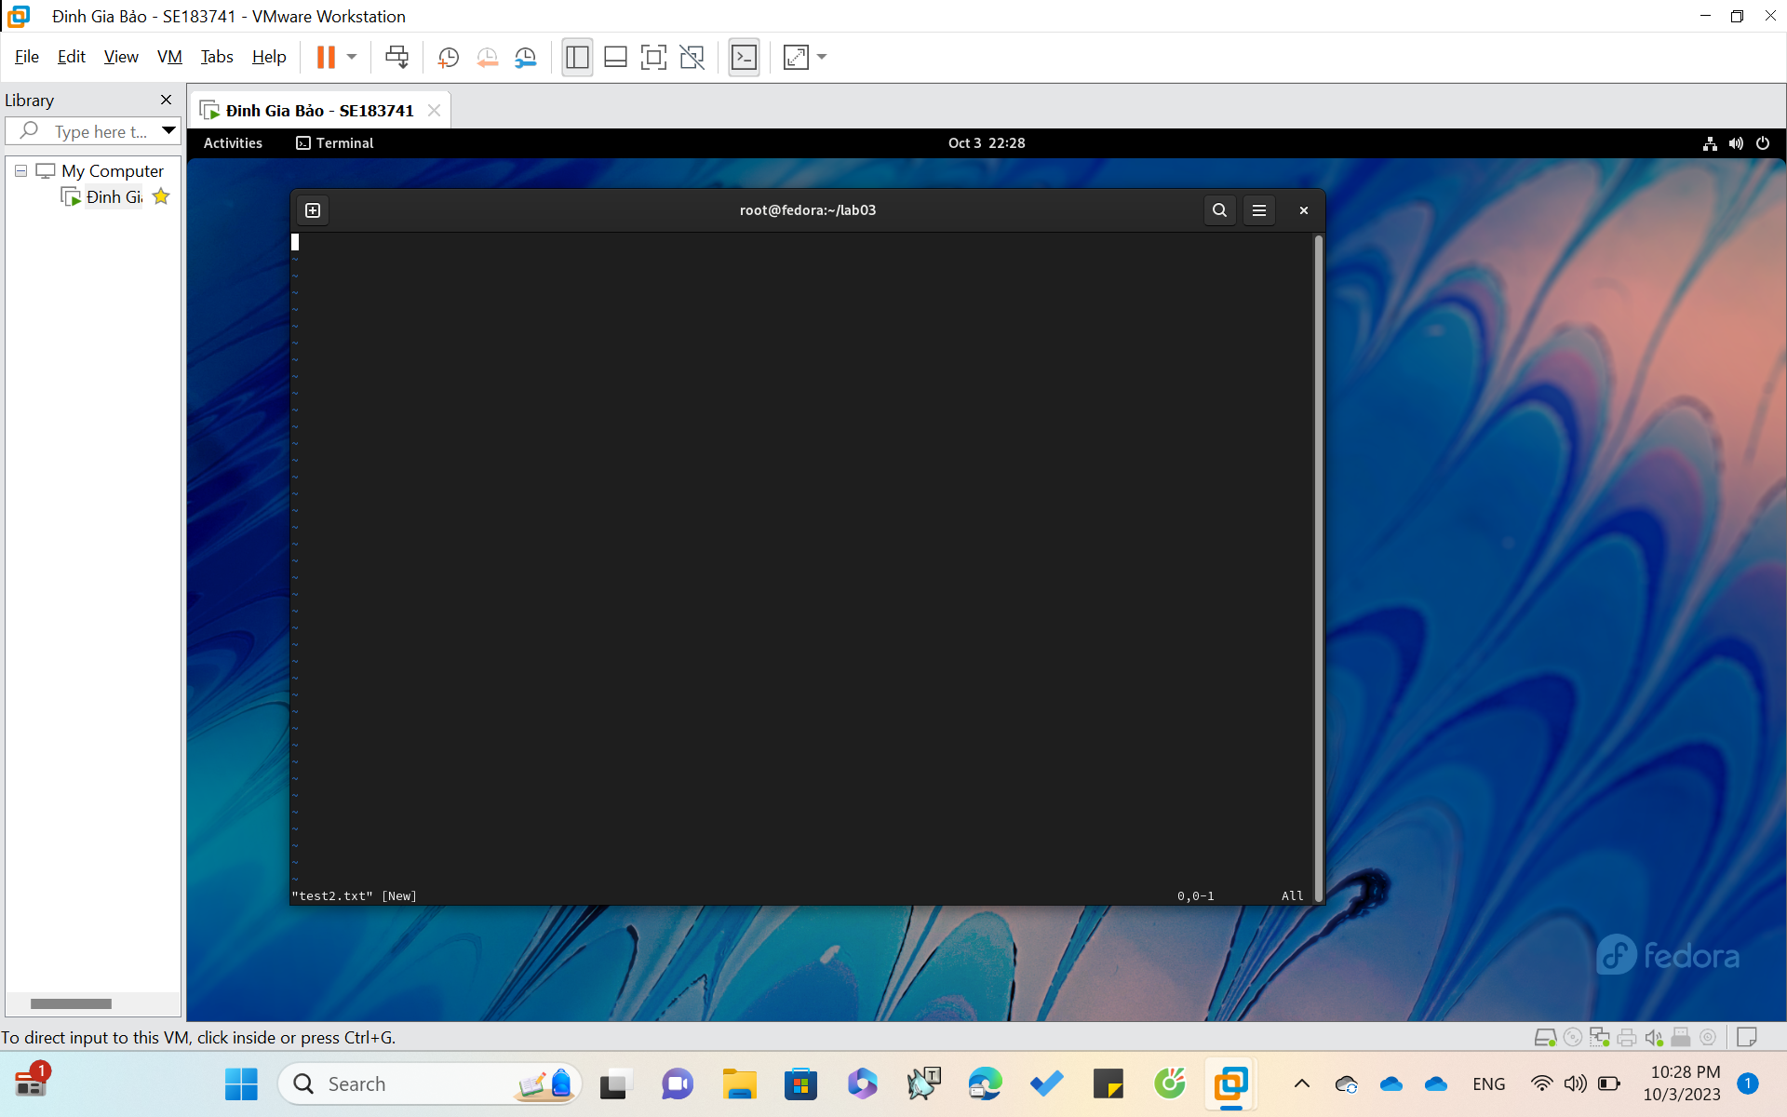

**Inside text2.txt**

**Press key i: insert or type the content (in the left)**

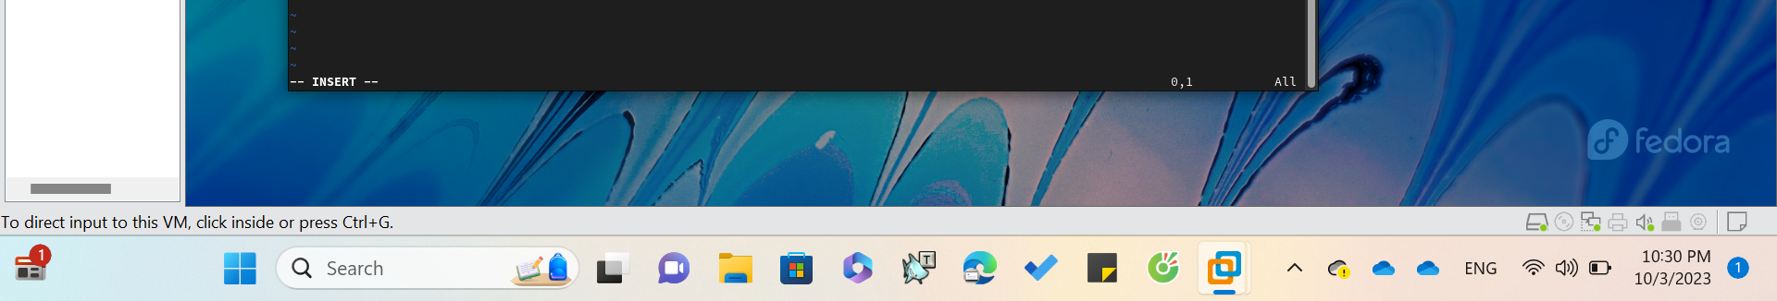

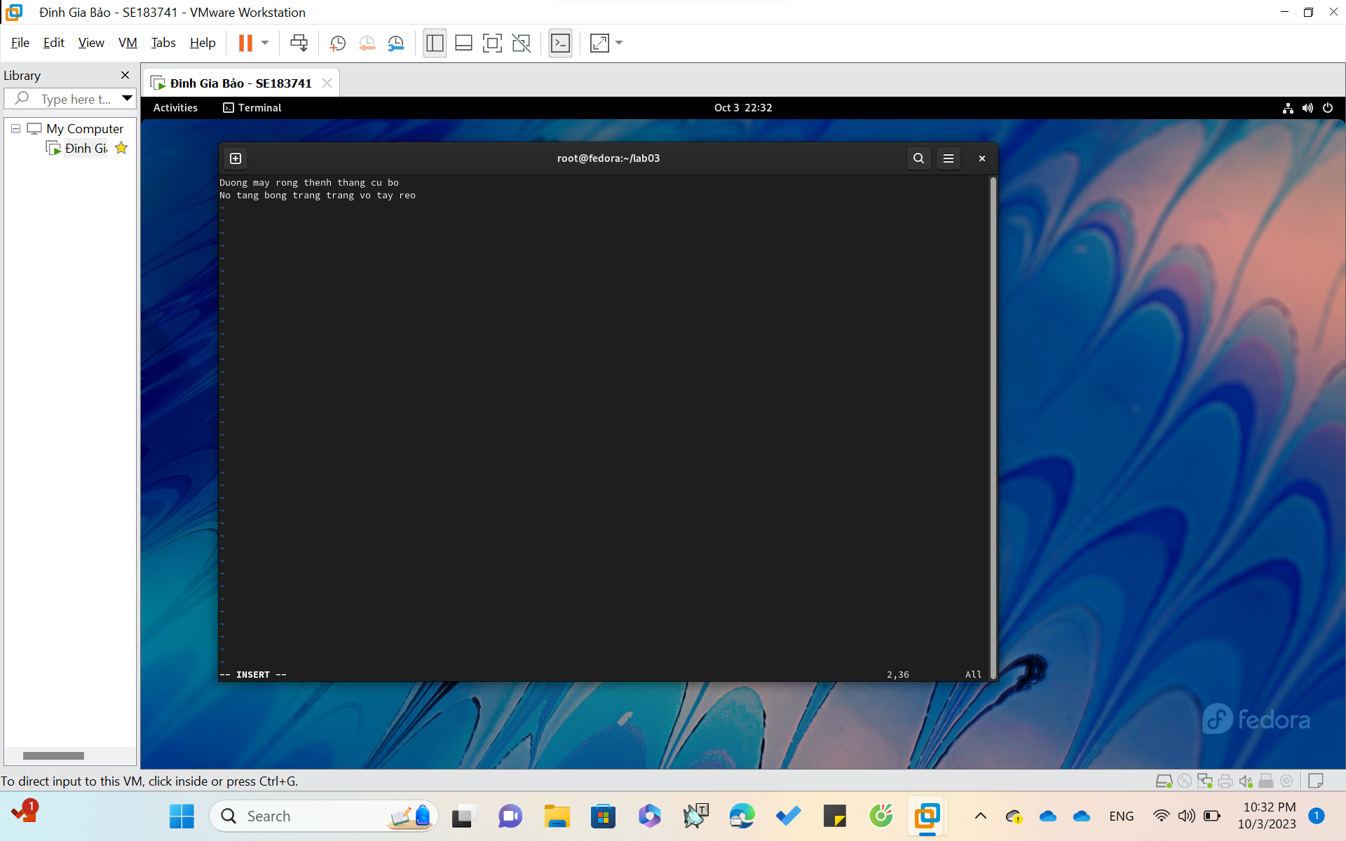

**To save your text:**

Use **“:w”** command



Ortherwise, if you use “**:q**” it will immediately exit vi



Finally, if you use “**:e!**” : it will delete all the content that typing after writing file

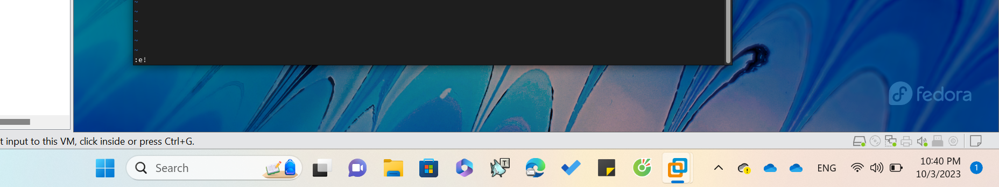

**END.**